Roll #: 17K-3795

Name: Muhammad Mustafa Manga

Assignment #: 01

**Human Computer Interactions**

1. Sending message “Hello World” to Hasnain.

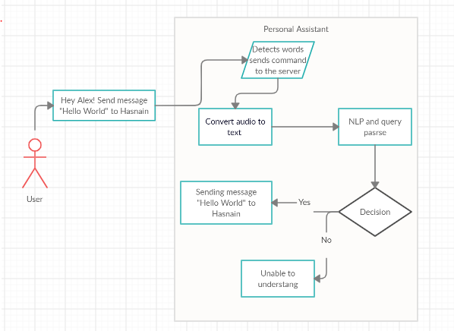

Other use cases include,

1. Setting a routine (calendar events).
2. Sending a message / communication.
3. Making a query or search.
4. Setting phone functions and setting.
5. Opening an application or playing music etc.
6. Making notes / reminder.

**2.**

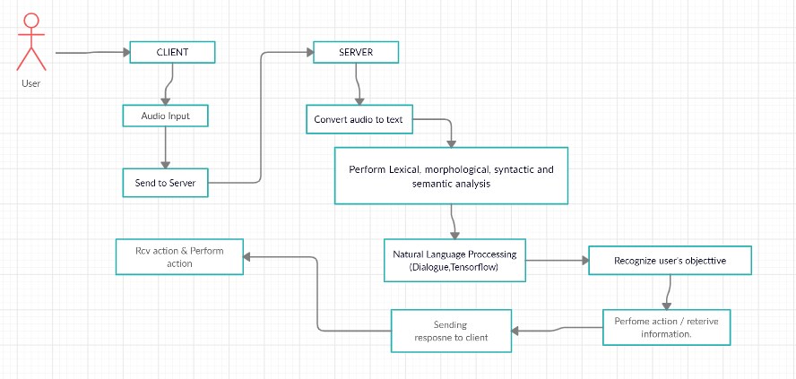

**a.** The desired answer will be fetched from the server after system will do multiple analysis on request then perform action recommended by the NLP model (trained to understand the general requests from the users).

**b.** System maintaining Database on server side in which all users have their unique ids. Upon request system fetches required personalized data using user id or also by accessing history or previous searches try to give relevant result.

**c.** User will sends his request to server in audio format. Firstly, server convert audio / speech to text by using different techniques or algorithm which includes Lexical, morphological, syntactic and semantic analysis. There are several NLP trained model which try to understand converted text with respect to the context. The result also based on previous queries or history and then send response to client.